Project Design Phase-I
Solution Architecture

Date | 26 October 2026
Team ID | Individual
Project Name | EV Market Intelligence Dashboard (Tableau)
Maximum Marks | 4 Marks

Solution Architecture:
Solution architecture is a complex process – with many sub-processes – that bridges the gap between business problems and technology solutions. Its goals are to:
- Find the best tech solution to solve existing business problems.
- Describe the structure, characteristics, behavior, and other aspects of the software to project stakeholders.
- Define features, development phases, and solution requirements.
- Provide specifications according to which the solution is defined, managed, and delivered.

Sample Solution Architecture Diagram:
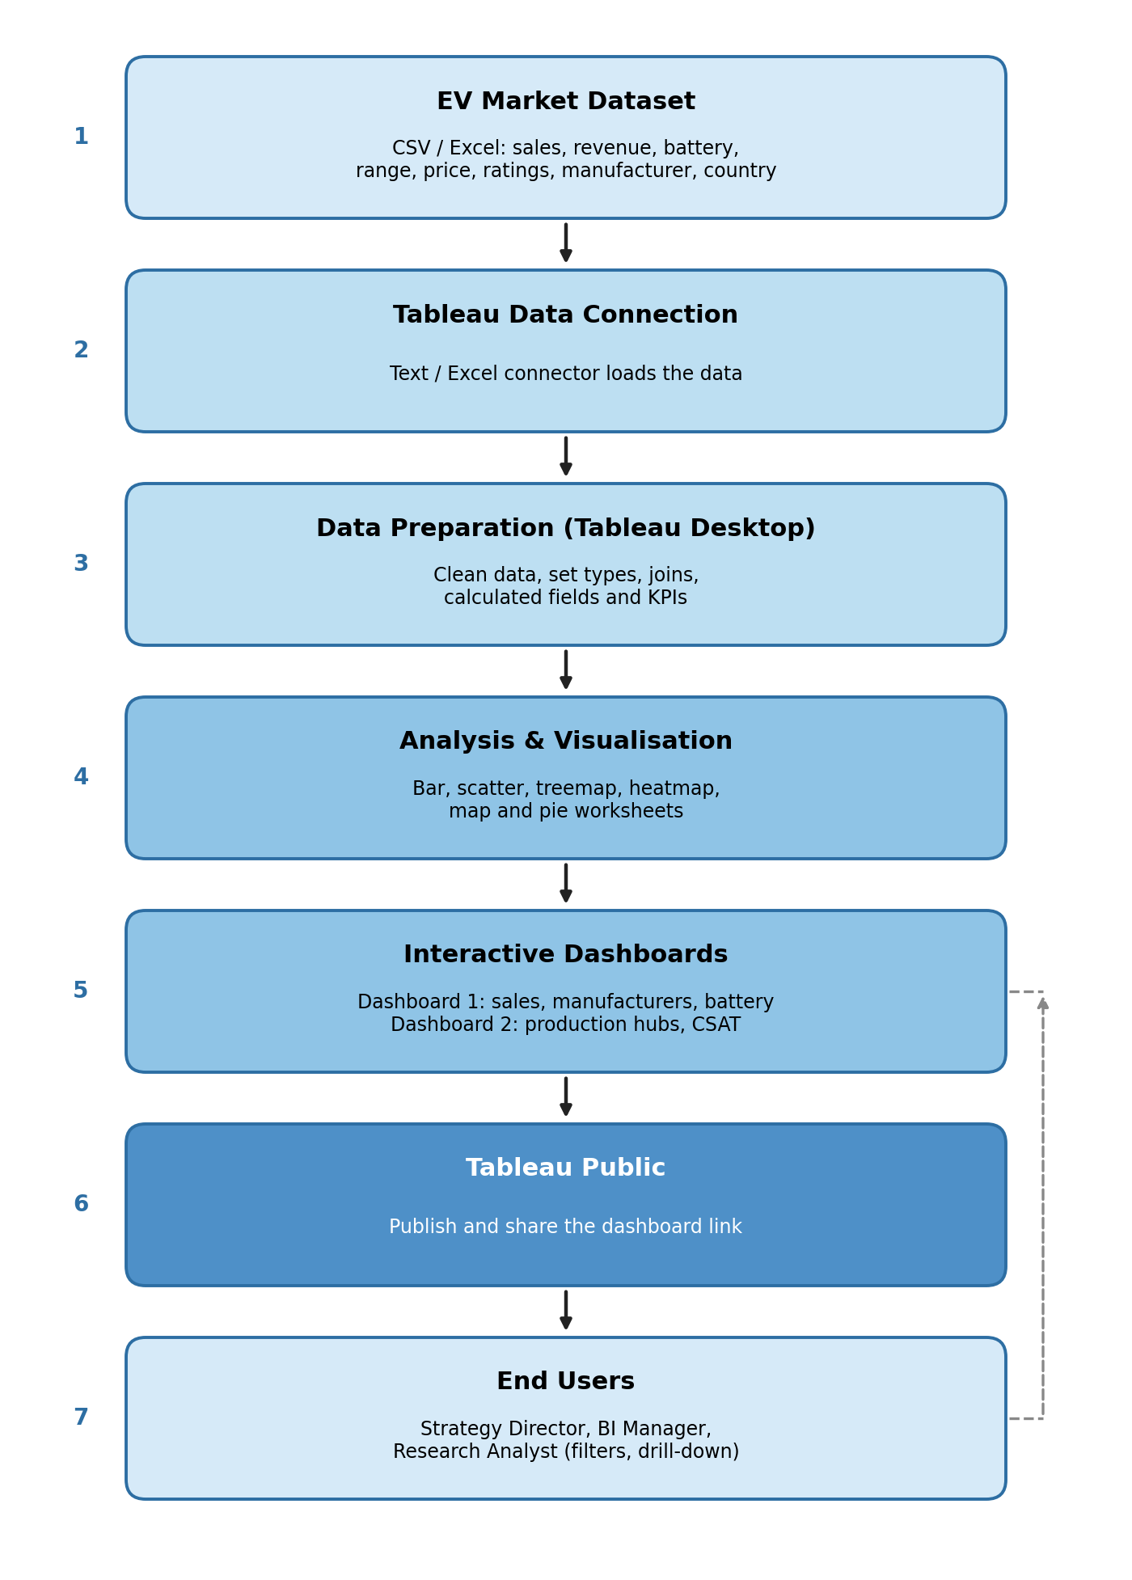

Component Description Table
Component Name | Description / Role in Architecture | Technology Used
EV Market Dataset | Source data on sales, revenue, battery type, range, price, ratings, manufacturer and country | CSV / Excel file
Data Connection | Loads the dataset into the analytical environment | Tableau Data Connection (Text / Excel connector)
Data Preparation | Cleans data, sets data types, joins tables and creates calculated fields and KPIs | Tableau Desktop
Analysis & Visualisation | Builds worksheets for sales, market share, battery technology, range, production hubs and CSAT | Tableau Desktop (bar, scatter, treemap, heatmap, map, pie charts)
Interactive Dashboards | Combines worksheets into Dashboard 1 and Dashboard 2 with filters and tooltips | Tableau dashboards
Publishing & Sharing | Hosts the dashboards online and shares the link with users | Tableau Public
End Users | Strategy Director, BI Manager and Research Analyst explore, filter and compare insights | Web browser (desktop or mobile)

